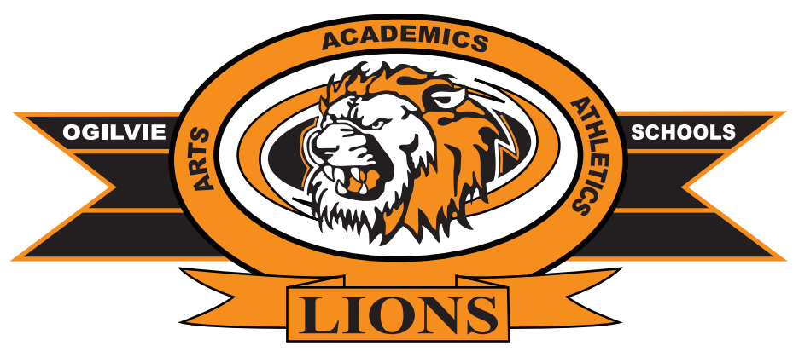
Ogilvie Public Schools – ISD 333
333 School Drive
Ogilvie, MN 56358
Phone: 320-272-5000 Fax: 320-272-5072
Kathy J. Belsheim, Superintendent 320-272-5075

Suzanne Davis, 7-12 Principal 320-272-5005 Ryan Koenigs, Pre K-6 Principal 320-272-5055
Benji Besser, Activities Director 320-272-5040 Brooke Stulc, Business Manager 320-272-5077

To: All Certified Staff

From: Kathy Belsheim, Superintendent and Sue Davis, 7-12 Principal

Re: Posting of Position

Date: May 30, 2023

Ogilvie Secondary is seeking applicants for a Middle Level/High School EBD/ABS Teacher starting for the 2023-2024 school year.

Description: Experience working with middle and/or high school age EBD students; knowledge and experience writing IEP’s, knowledge of MN EBD/ABS criteria and the evaluation process including Functional Behavior Assessments; knowledge of due process procedures; ability to work with a team; training or willingness to be trained in Crisis Prevention Intervention (CPI); and excellent oral and written communication skills

1.0 FTE Position as: Middle Level/High School EBD/ABS position. This is a permanent and full-time position starting in August 2023. Successful applicant must have a Minnesota EBD license; Grades 5-12, 7-12 or Middle School and ABS licensure. Coaching/advisor positions are available.

Salary: Based on District Teachers’ Master Agreement (Q Comp pay is also available.)

Duty Days: 147 student contact days; additional professional development days. (Ogilvie educates with a 4- Day School Week structure; Monday is typically the non-school day.)

Application Procedure: If interested, please send a letter of interest, resume, three (3) letters of recommendation, transcripts, Minnesota teaching license and District application (found at www.ogilvie.k12.mn.us) to Teri Belsheim at tbelsheim@ogilvie.k12.mn.us or Ogilvie High School, 333 School Drive, Ogilvie MN 56358.

For further information, please call 320-272-5005 to speak with Sue Davis, 7-12 Principal, Ogilvie Public Schools, 333 School Drive Ogilvie, MN 56358. You may also email sdavis@ogilvie.k12.mn.us.

“Ogilvie Public Schools is an equal opportunity provider and employer.”

